Applying Leontief's input-output concept
to a postulated global economic order of the natural world
Result and conclusion

Paper presented to the
16th International Input-Output Conference
Istanbul, Turkey, 2-6 July 2007
Final Version, March 2007
by Helmut Maier

Address of the author:
Dr. rer. pol. Helmut Maier, Professor of Economic Analysis and Statistics,
Berlin School of Economics, Badensche Straße 50-51, D-10825 Berlin, Germany
Phone: +49 (0) 30 85789 136, Fax: +49 (0) 30 85789 199, e-mail: oekonom@fhw-berlin.de

Preliminary remarks

We introduce the idea and hypothesis of a global economic (and financial) order within the natural world, briefly, for details see Maier (2003, 2005, and 2006). The door to this order opens when we look at natural phenomena with “eyes of the economist”. Basic characteristics or axioms are: Every good and service has its price and not only scarce goods and services like in traditional economic theories. Creatures are identified (not only but also) with enterprises which work profit oriented in order to live and survive. Species and populations, respectively, are identified (not only but also) with industries and commodity groups, respectively, whose representatives (despite unawareness) mutually provide themselves specific advantages, and on markets against “money” exchange (intermediate) goods and services, respectively. But its final product which is “specific living biomass of her own species able for services” any creature produces, restores, consumes, and demands for itself, the latter called final self-demand for life and living biomass, respectively. Therefore, within this natural order any creature has to pay for its final product (and service) life and finance it, respectively, by itself. As mean of payment and equivalent of money, respectively, “energy” is identified which occurs in different types as moving, thermal, electrical, potential energy etc. (like money in different currencies), and which is convertible and transferable (like money). Using the natural phenomenon “deer are grazing on a meadow near a forest in the evening” as standard example, the “transfer of energy” (transfer of money) from buyer “deer” to supplier “grass population” on the market place “meadow” of this “food market” is proved “by eating” the good “grass”. The micro-economic proof succeeded via the detection of the so-called “dual market” to the same natural phenomenon which is a “transport market” in this example, and which allows a so-called “dual interpretation” of the same natural phenomenon, in this example called “seeds of grass are waiting for transport to settle somewhere else”. Simultaneously, this proof describes the economic benefit of the “grass population” as market participant which is not revealed to the observer who sees how the grass is being “destroyed” or “killed” by “eating”. Within this postulated economic order the sun plays the role of the (independent and autonomous) central bank, any creature holds a bank because it is able to convert energy (money). The “natural state” is defined by the sun, the earth including its atmosphere, and different planets of sun’s planet system, its population is defined by the different species of creatures, its laws are defined by the known (and may be unknown) natural laws, and its social top aim is “conservation of life”. This “natural state” finances its activities (directly and indirectly) by energy (money) from the sun (central bank) and by taxes from populations, the latter are transfers of thermal energy (money transfers) from the creatures to their environment, reversely subsidies are energy transfers (money transfers) from the environment to the creatures (transfer of thermal energy, for instance). For illumination, Table 1 lists the introduced axioms, Picture 1 and Picture 2 show the market specifications on the “food market” and its dual “transport market” within the dual phenomena “deer are grazing on a meadow near a forest in the evening” and “seeds of grass are waiting for transport to settle somewhere else” including the “transfer of the payments”.

- The natural state consists of the planet system of the sun.
- Its laws are the physical laws.
- Its population is the totality of creatures.
- Its social top aim is conservation of life.
- Creatures act and react with incomplete information.
- Every product and service has its price.
- Transferable and convertible equivalent of money and price specification is energy.
- Markets occur as so-called dual markets; suppliers on the one market represent the demand on the second (dual) market, and vice versa.
- Industries are represented by populations and species.
- Creatures represent enterprises and consumers (clients) in one subject: They produce, consume and finance their final product living biomass of their own species by themselves.
- Central bank is the sun, creatures include a bank.
- The natural state finances its activities by energy of the sun (sunlight), taxes and subsidies. Taxes are energy transfers from the creatures to the environment; subsidies are energy transfers from the environment to the creatures.

Table 1: Axioms of the postulated economic order of the natural world

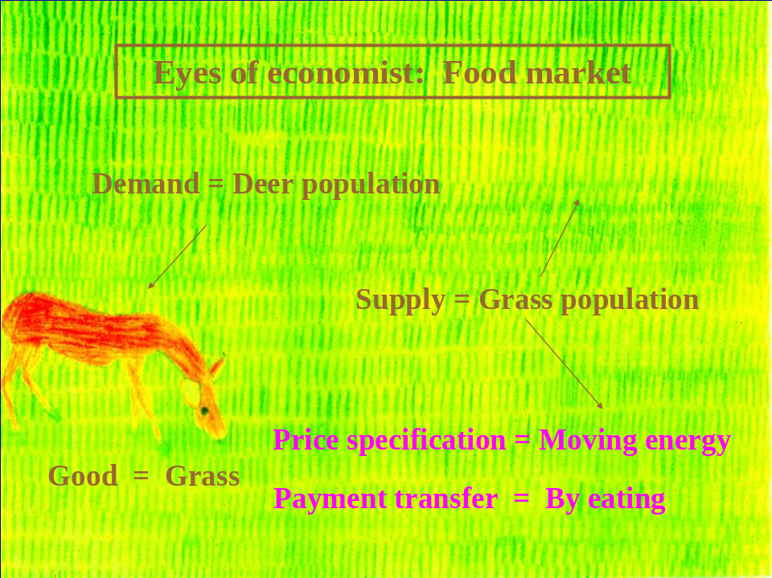

Picture 1: First economic identification of the natural phenomenon deer are grazing on a meadow near a forest in the evening: The eyes of the economist detect a food market with the “deer population” as demand, the “grass population” as supply, and the “food grass” as the good. The invisible payment moving energy of the “deer population” is transferred by eating to “seeds of the grass population” included in the food like to passengers in a bus. Thus the paradoxical question after the benefit of the grass population when grass is “destroyed” by grazing gets an evident answer. Source: Maier (2005, oral power point presentation, slide 13, drawing by Alexander Maier).

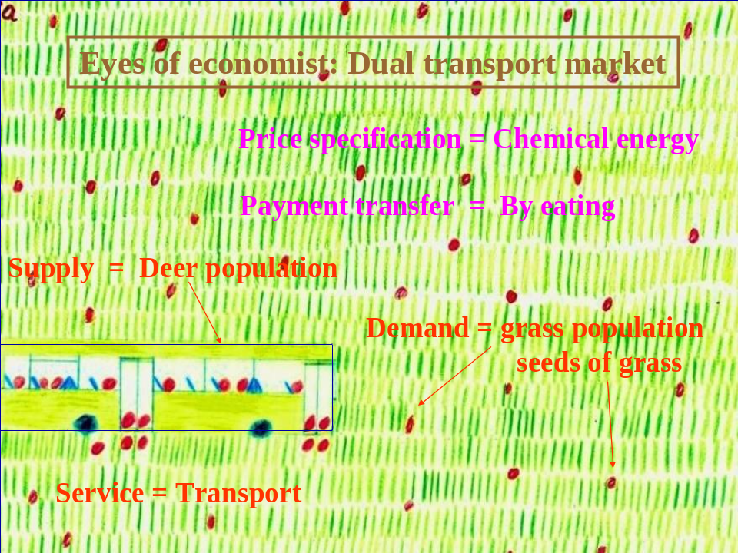

Picture 2: Second (dual) economic identification of the natural phenomenon deer are grazing on a meadow near a forest in the evening: The eyes of the economist detect a transport market with the “deer population” as supply, the “grass population” as demand, and the service “transport”. The invisible payment chemical energy (of the “food grass” around the seeds) is transferred by eating from the “grass population” to the “deer population”. Thus this natural phenomenon may be also called seeds of grass are waiting for transport to settle somewhere else. Source: Maier (2005, oral power point presentation, slide 12, drawing by Alexander Maier)

We mention the intermediate result of a micro-economic analysis by modelling each of the dual markets between grass and deer population as a neo-classical single good market (with a time delay in demand functions) separately, by coupling and closing these dual markets, and, finally, looking at the behaviour of production and prices (in energy units) for t going to infinity in case of balance on each market, for details see Maier (2006, p. 38): “The coupled and closed system works in equilibrium then and only then when, firstly, the (balanced) total mass of food being produced is equal to the (balanced) total mass of food being transported, and, secondly, when the (balanced) energy to produce a unit of food is equal to the (balanced) energy to transport a unit of food”. Using a graphical representation, this means: “The coupled and closed system works in equilibrium then and only then when all four straight-lines of supply and demand functions meet each other in the same point”. We note that the two conditions satisfy the physical laws of conservation of mass and of energy because during producing and transporting food (by grass and deer population) no mass is lost or gained, and no energy is lost or gained, respectively, within this closed system. Picture 3 demonstrates this result which is a very strong support of the hypothesis of a global economic order within the natural world with energy as equivalent of money. But because of the unavoidable exclusion of natural attributes like sun, air, environment within the neo-classical approach, there is a need to model these dual phenomena between grass and deer population and their corresponding dual markets on macro-economic level including missing specifications up to now, the latter is subject of this analysis and we use Leontief’s concept. Aim of this combined empirical and analytic approach and test is to reject or accept the hypothesis of a global economic order in the natural world with energy as price specification and money equivalent on macro-economic level. Criterion is whether the results make sense.
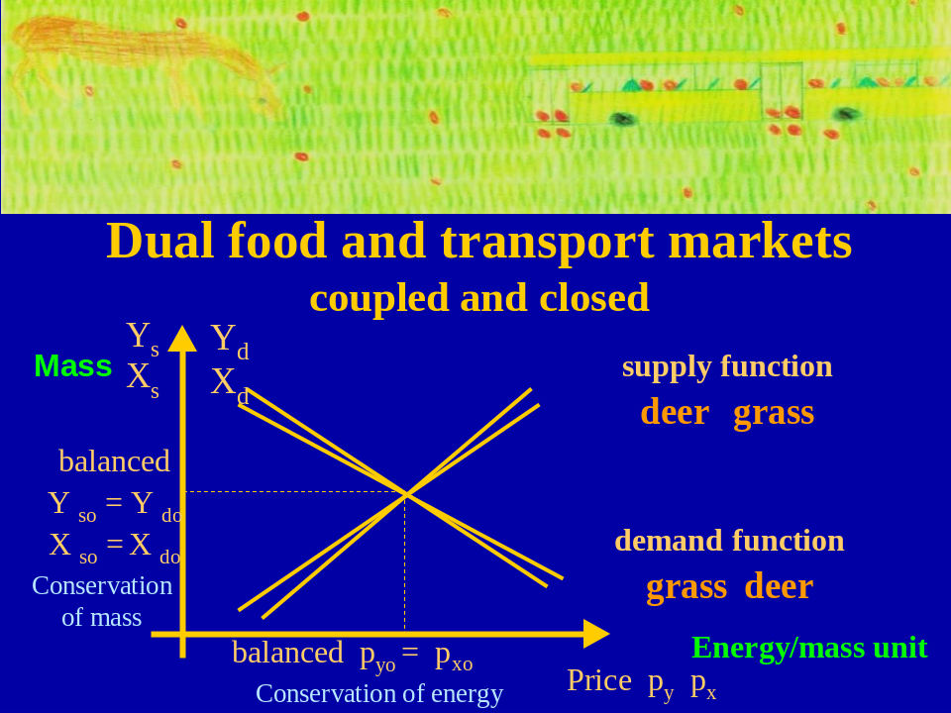

Picture 3: Coupling and closing the dual food and transport markets. The picture illuminates the central micro-economic message: Both populations of grass and deer can exist when their benefit/ returns on this market where they supply goods and services, respectively, balance their costs on the other market where they demand for goods and services, respectively, and hence have to pay. Thus the cost (in energy units) of the grass population to produce a mass unit of grass must be equal to the cost (in energy units) of the deer population to transport this mass unit of grass to a distant location, and the produced mass of grass must be equal to the transported mass of grass. These conditions satisfy the physical laws of conservation of energy and mass in a closed system. Notations of food market: X_{s} denotes the supply of food by grass population in mass units, X_{d} denotes the demand for food by deer population in mass units, p_{x} denotes the price for a mass unit of food grass in energy units, X_{so} denotes the balanced supply of food by grass population for t going to infinity in mass units, X_{do} denotes the balanced demand for food by deer population for t going to infinity in mass units, and p_{xo} denotes the balanced price for t going to infinity for a mass unit of grass in energy units. Notations of transport market: Y_{s} denotes the supply of service transport by deer population in mass units, Y_{d} denotes the demand for service transport by grass population in mass units, p_{y} denotes the price to transport a mass unit of food grass somewhere else in energy units, Y_{so} denotes the balanced supply of service transport by deer population for t going to infinity in mass units, Y_{do} denotes the balanced demand for service transport by grass population for t going to infinity in mass units, and p_{yo} denotes the balanced price for t going to infinity for a mass unit of grass in energy units. Source: Maier (2005, oral power point presentation, slide 20).

1 Creating the design of an input-output table of the natural world

Approach

Theoretical basis is an open ended and static Leontief-model. Open ended means that we take the final demand for goods and services as a given exogenous variable which we don’t estimate within this model, static means that the values of all variables of demand, supply, price, etc., refer to the same period, imagine a year. Why a Leontief-model? Answer: Within the System of National Account SNA of United Nations, this model is in use, its empirical equivalents appear in Official Statistics as so-called input-output tables to prices at work, for example. They describe observable economic activities usually on national level within a period of one year and balance total production input and output according the principle of a closed economic cycle within one year. Prices at work mean that those prices are considered which are paid when the goods and services, respectively, leave the enterprises of production. Imagine such an input-output table of Official Statistics, for instance the input-output table of the German Statistical Yearbook of 2004 which maps the economic activities in Germany within the scope of twelve industries. We take this table as a guide or reference, Table 2 shows this guide in a simplified form including two industries.

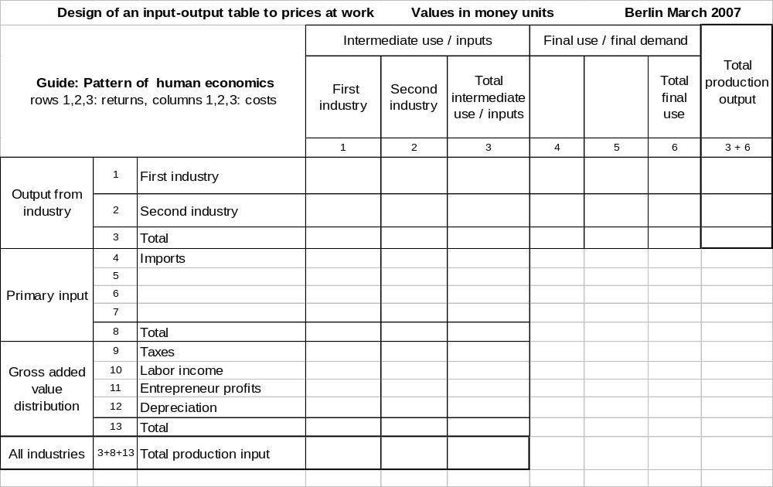
Table 2: Design of an input-output table of a human economy reduced to two industries

We intend to create an equivalent draft for the totality of species and populations within the natural world. This draft we call the design of an input-output table within the natural world. Because of lack of (reliable) statistical data this table includes fictitious figures, but the latter are for illumination only, and they are not decisive for the result of this analysis and test, this we note. We start with the simple model of the dual food and transport markets between deer and grass population. This because we have in mind that the exclusion of natural attributes like sun, air, environment, and others is like a bed of Procrustes, really, which is too small. Now we intend to eliminate this objection against the results up to now. Therefore, we imbed the phenomenon deer are grazing on a meadow near a forest in the evening and its dual phenomenon seeds of grass are waiting for a transport service to settle at a different location, and the dual food and transport markets, respectively, with the populations of grass and deer as co-operating partners in a larger environment. Within Leontief’s concept we have to ask for the different specifications of costs for the inputs and returns from the outputs, and we have to state the balance between total costs and total returns within a reference period. To get these specifications we start with the specifications of an input-output table for the two populations of deer and grass plants. According our hypothesis that populations (not only but also) equal industries, we identify the two industries with food production industry executed by grass population, and with transport service industry executed by deer population. And we assume that both populations act and react in order to get an economic basis for living. If the result looks trustworthy we extend this table using mathematical language to the design of a general input-output table of all creatures, and evaluate the results, finally.

Matrix of transactions

We look at the matrix of transactions. This matrix is represented by the fields of row 1, 2, and column 1, 2. Food production industry provides the good food for transport service industry let’s say in value of 100 energy units (what ever this unit is) per year, these 100 energy units represent costs of food production industry to provide this food in its work on ground of the meadow. Vice versa transport service industry provides service transport in value of 100 energy units as well, these 100 energy units per year represent costs of transport service industry from work on ground of the meadow to another location let’s say forest. Using notations of the micro-analysis illuminated in Picture 3 these figures represent values of p _{x o} X _{s o} (total supply of food production) and of p _{y o} Y _{s o} (total supply of transport services) which are equal in case of balance. Other transactions from food production industry to food production industry, and from transport service industry to transport service industry are missing in these dual markets and we neglect them within this draft on macro-economic level as subordinate as well, hence we put a 0 into these places. So intermediate outputs (to other industries) as well as intermediate inputs (from other industries) are in total 100 energy units per industry and year, and 200 energy units for both industries per year, see Table 3. The present picture of this input-output table showing (and including) only the transactions and the balance of total outputs and inputs meets the results of the micro-economic model in case of balance, this we note.

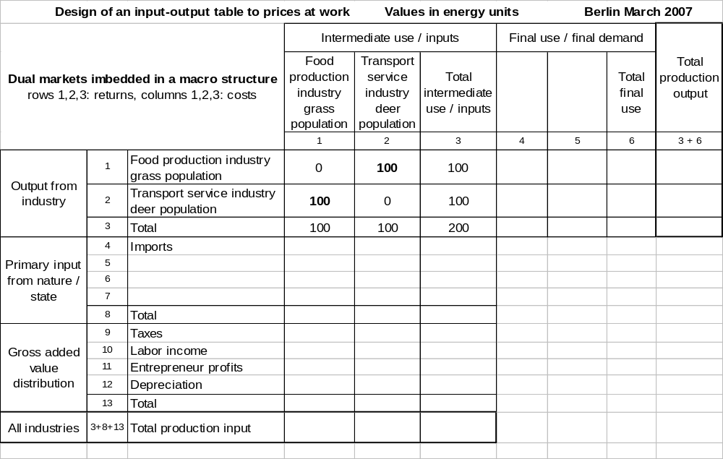
Table 3: Including the matrix of transactions due to the balance of mutual payments
on the coupled and closed dual food and transport markets in a period

Cost pattern

Now we turn to the extension of the micro-economic model. We identify the total cost pattern which is mapped within this input-output table by the fields of columns for each industry. Within the guiding input-output table of Germany these are twelve columns and a thirteenth column for the sums. So we have two columns for the costs of deer and grass, and a third for the sums. The deer (transport service industry) have costs for transport which are far above 100 energy units per year, this is out of doubt. The payment of 100 energy units per year they get from grass population covers a fraction of the total costs of the deer, only; like the payment of a passenger in a bus covers proportional costs. Reversely, the grass population (food production industry) has costs for producing the food grass which are far above 100 energy units per year. The payment of 100 energy units per year the grass population gets from the deer covers a fraction of the total costs of the grass population as well, only; they pay for this grass they eat. Looking at the structure of the input-output table, there are additional posts for Primary inputs and the Gross added value. So we have to look for different posts of input of the deer from the environment, and we have to look for different posts during the production process as well. As Primary inputs we consider four classes of specifications: Aerial, liquid, solid inputs from environment, and input from sun; think of the inputs air for breathing, water for drinking, solid for eating (different materials than grass), and sunlight. Now we have to identify the posts of the gross added value which according SNA include taxes, labour income, profits, and depreciation. We start with the post for labour income. We observe deer are eating, breathing, drinking, digesting, moving, and waste ejecting. In eyes of an economist this is labour, undoubtedly, therefore there exist costs. In addition, all these activities are to co-ordinate and to manage by the head of the enterprise deer, these costs we consider as profits (or add them to the costs for labour, this is subordinate). Reversely, we observe seed of grass is growing with primary inputs (including waste in which it is ejected after transport), in eyes of an economist this is labour and management as well, undoubtedly, and therefore there exist costs. Now we shift to the post depreciation, and we have to identify an equivalent within the nature. Within the input-output concept this post covers yearly costs of capital goods which can be used for more than one period. These yearly costs measure and balance the loss of value of these capital goods per year. We substantiate as follows: As deer have a limited life expectancy, there is a need for reproduction of the deer population from time to time when the transport service industry shall be maintained which is aim of each enterprise. Reproduction activities we have not considered until now. But they exist without doubt hence there exist costs (for procreation, creation, education). Considering the total costs of deer population for reproduction, and dividing this figure by the life expectancy of a deer (in years), we get a measure and an estimation for the amount of the depreciation of transport service industry which is the deer population. Reversely, we include depreciation costs of grass population excluding those costs for transport of seeds which are already mapped within the matrix of transactions. We continue with the post profits which are profits of the entrepreneurs. These profits are costs for the transport service industry like the costs for labour. As the deer (and the grass plants) are both, entrepreneurs as well as workers, we have to decide which activities of deer population are workers’ activities and which are entre-preneurs’ activities. To avoid this decision, at this status we simply could add this post to the post labour, and we could call the combined post labour, profits/living. This notation would make sense as well because maintaining the transport industry means existing of this industry, and the latter means living of the deer population. We turn to the last post taxes. In eyes of economist taxes are paid to the state. How we identified the natural state, we could also say the state is the total environment without the different populations. Hence taxes are energy payments which any economically active representative of a population has to transfer to the state, and within the natural order, any creature is economically active during its whole life (as worker as well as entrepreneur in one). We observe that deer lose thermal energy (heat), continuously, when temperature of environment is lower than its own temperature, and this energy is transferred into its environment. This loss of energy we identify as tax payment of deer population to the state. Because deer have (developed) a pelt they keep these payments low. If the deer lie together, for example at night, they have a reduced tax. These taxes remain within the state (nature, environment) or they are provided to different representatives of populations which get this energy units (heat) like subsidies, this makes sense as well. Furthermore, a transfer of energy of any grass plant into its environment is observable, too. This loss of energy we identify as tax payment of grass population to the state. Now all cost specifications (costs for inputs) needed for this input-output table are identified within grass and deer population. We include figures (in energy units) into these two columns of this table, for illumination. As figures for the costs for primary inputs of food production industry, we take 15 for gas/air, 20 for liquid/water, 10 for solid materials/earth, and -40 for light from central bank sun, as figures for the gross added value of food production industry, we take 5 for taxes, 35 for labour, profits/living, and 25 for depreciation/reproduction. As figures for the costs for primary inputs of transport service industry, we take 20 for gas/air, 15 for liquid/water, 5 for solid materials/earth, and -30 for light from central bank sun, as figures for the gross added value of transport service industry, we take 15 for taxes, 50 for labour, profits/living, and 25 for depreciation/reproduction. To avoid misunderstanding we note that the positive figures of primary inputs describe expenses of the two industries to absorb these materials, and not the energy values of these absorbed materials. The negative figures for inputs from sun consider the balance between the costs to absorb sunlight and the profit from absorbed sunlight (heat), this balance is negative, in general. Hence the sun provides a subsidy to food and transport production but not all. We complete the input structure by sums for expenses for primary inputs (5 grass, 10 deer), for gross added value (65 grass, 90 deer), by sums for total production input (170 grass, 200 deer), and finally by the sum of both total production inputs which is 370 energy units. Result: Total costs of grass population for food production are 170 energy units per year, and total costs of deer population for transport services are 200 energy units per year, see Table 4.

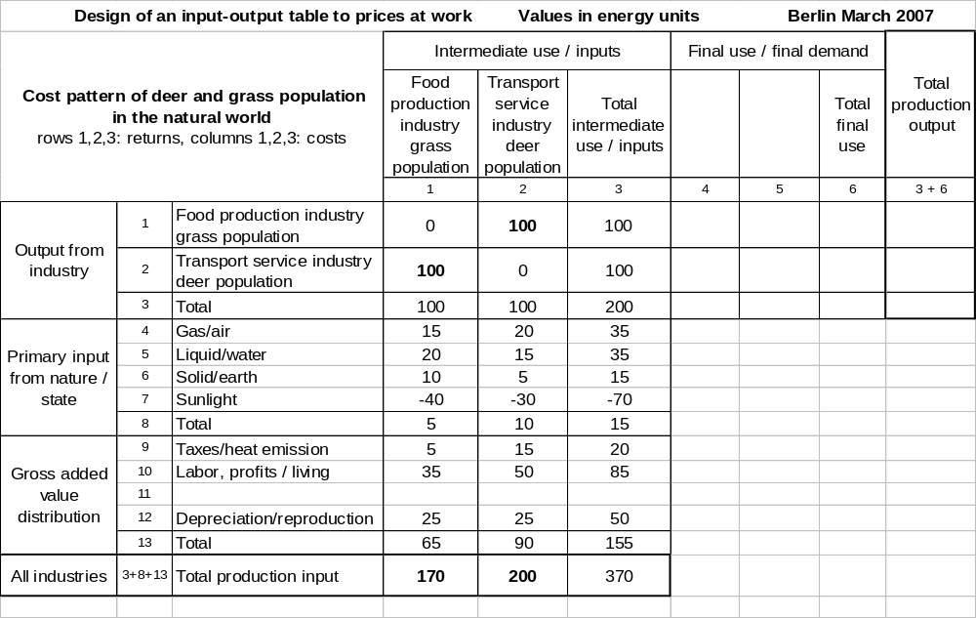
Table 4: Including the cost pattern of the dual markets, negative figures mark subsidies

Benefit pattern

We turn to the benefit specifications which are given by the returns from outputs of each industry (food production, transport service). Outputs and returns, respectively, for grass and deer population and together are mapped in the first three rows of this table. As we consider a closed economic cycle, the total costs (for inputs) must be balanced by the total returns from outputs. Therefore we continue with the column of total production output and transfer the figures 170 for food production industry, and 200 for transport service industry, respectively, of the totals of production inputs. We observe a gap: These output values (170 and 200) are by +70 and +100, respectively, far over the figures both industries (populations) get as returns from their outputs to each other. If we can’t close this gap both populations of deer and grass can not exist because they need more energy for inputs than they get from outputs within this extended economic model in the natural world. Thus we have to look for a source for returns, in addition. If we fail we can reject the hypothesis of an economic order operating in the natural world, especially we can forget that energy serves as money equivalent in the natural world, this we note. This means that we are at a decisive point of the analysis.

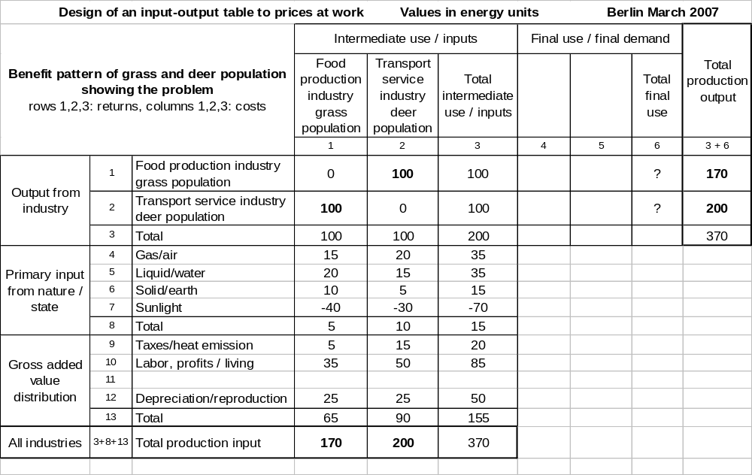
Table 5: Including the benefit pattern of grass and deer population, starting point and showing the
problem: How grass and deer population finance costs which are not balanced by returns
from intermediate outputs?

Because this gap appears in the extended system (with Primary input and Gross added value) and didn’t occur in the micro-economic concept, intuitively we try to localize the source for this considerable gap (in the output positions) within these new input positions. What could it be? As we have no idea, we observe and analyze what is going on when deer and grass populations are producing (working), this is an economic procedure, and therefore the eyes of the economist should be useful. We start with the deer. We observe that they are alive, breathing (in and out), drinking, eating, waste ejecting, moving, etc.. What is the economic meaning? Answer: These activities indicate the production process, the deer takes different input materials into his body, decomposes them within his body by digesting, and puts it together to these new materials he needs for living, those he can’t use further will leave his body. This is hard work. Their bodies are the factories which work up special input materials to those materials they need for life, for example to bones. And this factory is busy, obviously. Therefore, there must be a post we forgot in the considerations. Searching in the economic literature, we find a first answer within the theory of surplus value of labour of Karl Marx, we identify this missing position with the surplus energy released or gained by producing life and living biomass, respectively, hence this post is an output and is to be considered with the output positions. We control this conclusion by a different consideration: This post surplus energy we note in this table under the positions which denote the final use or final demand, respectively. We ask: Who demands for this surplus value released by producing biomass? The simple answer is: The deer themselves! At this point we detect a new characteristic of the production process within the natural order which appears quite contrary to production and distribution processes we meet in human economics. We have in mind, usually, that producer and user (customer) are two different subjects, the producer sells a good or service to a customer and the user (customer) pays money to the producer. Now we learn: Within the natural order producer and user (customer) is the same subject! Hence the final user (customer, here the creature deer) has to pay the money for the good it demands for - and this product is the living biomass of its own body able to provide services - to the producer (here the same creature deer). In other words: Every creature, here the deer, has to finance the production of its own body able to provide services by itself. And (only) because of the existence of a surplus value in energy units by producing living biomass as well as the accumulation of this energy inside its body, every creature (here the deer) is able to finance the production of its own living biomass at all. Reversely, if a surplus value in energy units wouldn’t exist during the process of producing biomass, the creatures could not finance their own production and would not produce themselves. Hence this post can be identified as the profit of the enterprise creature, too; the creatures produce their own biomass because there is a profit in energy units. This different consideration executed to control the previous result corresponds to the second answer due to the theory of enterprises which substantiates the existence of an enterprise by the existence of a profit, and it confirms the first finding on basis of Marx’ theory. The application of both contrary theories delivers the same result. As we observe that creatures are producing and living, respectively, their mere existence is the empirical proof for this surplus energy gained by producing biomass, and energy profit gained by producing life, respectively. This important result and substantiation we gained by mere observation and applying Marx’ theory of surplus value of labour and theory of enterprises, respectively, this we note. We control this detection by a third and independent considera-tion. As we observe a deer has a pelt and this pelt is opportune to save taxes. But when a deer pays taxes (loses energy) it must have more energy inside his body than is outside in the environment otherwise the physical transfer of thermal energy would not occur. As it takes the input materials from the environment (grass, water, air, and other solid materials) are considerable cooler than it is in general, and because this thermal energy cannot come from sunlight alone because this deer (very often) lives without sunshine, the source of this energy must lie in his body. As the figures of this input-output table don’t include the energy values of the input materials (grass, water, air, and other solid materials) themselves but rather the costs the deer have to get these input materials which include a different energy value in general inside their bodies, we conclude that the source of this surplus energy lies within these materials, especially the grass which is transported by this deer, in the air, and in the water this deer consumes. In order to regain the payment (in energy units) for transport, and using primary inputs, any deer decomposes (by digesting) this grass, and composes its chemical parts to different materials it needs for living, for example bones, and for transformation into different energy types, for example kinetic energy for moving. This is observable (directly and indirectly). Result: There must be and indeed there are a lot of physical and chemical trans-formations and reactions, either they need energy or they release energy, obviously. There is no need that the economist knows the technical details of these transformations. But he needs the knowledge and assumption, respectively, that the bottom line of all these physic-cal and chemical actions and reactions is positive. Hence we conclude the hypothesis: By pro-ducing living biomass, the creatures get a positive bottom line of energy of all physical and chemical actions and reactions, respectively. Again we conclude: As the creatures are living their mere existence is an empirical proof for the existence of such a positive bottom line. After these three independent substantiations we become nosily. We try to demonstrate this profit and surplus value, respectively, by direct observation of concrete elemental biological production processes. For this, firstly, we consider the chemical reaction of quicklime, CaO, plus water, H₂O, to slaked lime, Ca(OH)₂ , during which heat (energy) is released. This heat is observable and measurable because the product slaked lime turns warm. This chemical reaction occurs with building construction, for instance. Creatures build up, too, bones for instance which consist of lime. Applying theory of enterprises and Marx’ theory, respectively, we identify the energy released as heat as the profit and surplus value, respectively, from the labour procedure to bond the single parts „quicklime“ and „water“ to the product „slaked lime“. Therewith an empirical evidence for the existence of this profit and surplus value, respectively, is found. Secondly, we consider the bio-chemical reaction of carbon dioxide, CO₂ , and water, H₂O, to glucose, C₆H₁₂O₆ , and oxygen, O₂ , which is executed during day-time by plants in their leaves, and which needs chlorophyll and sunlight (sun energy). With this production process there arises no profit and no surplus value, respectively. Reversely, for executing this reaction (production) there has to be added energy (money). Only, when this reaction in plants is executed in reverse direction during night-time with absence of sunlight that is when glucose by adding oxygen disintegrates to water and carbon dioxide, there is energy (money) released which this plant needs for life. Result: Within the nature we can observe (elemental) production processes which need money (energy) and which release money (energy). These two examples of elementary chemical reactions are compatible with our economic conclusion that the bottom line of all these chemical (and physical) reactions and transformations within the factory and body, respectively, of a creature must be positive. If it would be negative (and couldn’t be balanced by energy from sunlight) this enterprise could not exist economically. We note that the detailed (physical and chemical) proof that the bottom line of all physical and chemical actions and reactions, respectively, to produce living biomass is subject of biology discipline and not subject of the economist.

After the successful identification of the missing posts we turn back to the input-output table and include the missing figures 70 as released surplus value of energy of food production industry by grass population and 100 as released surplus value of energy of transport service industry by deer population into this table under the post final use / final demand, because both population demand for this surplus value of energy, use and produce it by themselves.

First draft and second draft

Guided by the input-output-table of Official Statistics we created a first draft for the design of an input-output-table at works prices, see Table 6. We learn that the initial demand for restoration (by food) of the deer population of amount 100 energy units leads to a total production output of 170 energy unites of the grass population which provides this food, and that the initial demand for reproduction somewhere else (by transport services) of the grass population leads to a total production output of 200 energy units of the deer population which provides these transport services. We learn as well that these initial demands are intermediate demands for the self-realisation of both populations. The figures 170 and 200 hide that both production processes are supported by the central bank sun by more than 40 and 30 energy units, respectively, because both of these figures are bottom lines between cost to get sunlight (positive) and subsidy from sunlight (negative). To illuminate this subsidy effect better it seems adequate to shift the latter figures to the output side as a separate post of the final use (because of grass and deer population demand for this subsidy) and thus deviate from the usual pattern of an input-output table. We discuss also whether it is possible to shift the posts of surplus value by living of 70 and 100 energy units to the two free positions of the matrix of transactions where there are the two nulls. As these returns are not transfers from one deer to another or from one grass plant to another, we hesitate to displace these figures into the matrix of transactions; using a closed Leontief-model we could do it. But we improve this first draft in a different detail: We separate the posts entrepreneur profits/living (assuming 2 energy units for grass population, and 6 energy units for deer population) and labour income/living from the post labour, profits/living without changing the total figures (35 energy units and 50, respectively). Thus we get a second draft of this input-output-table, see Table 7.

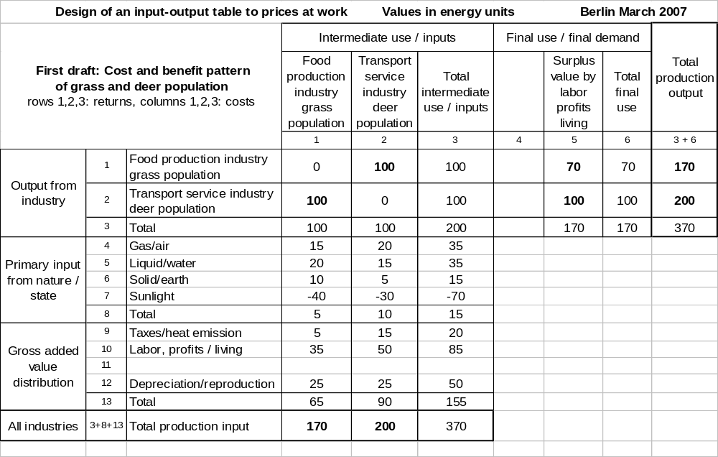
Table 6: First draft of the design of an input-output table with grass and deer population

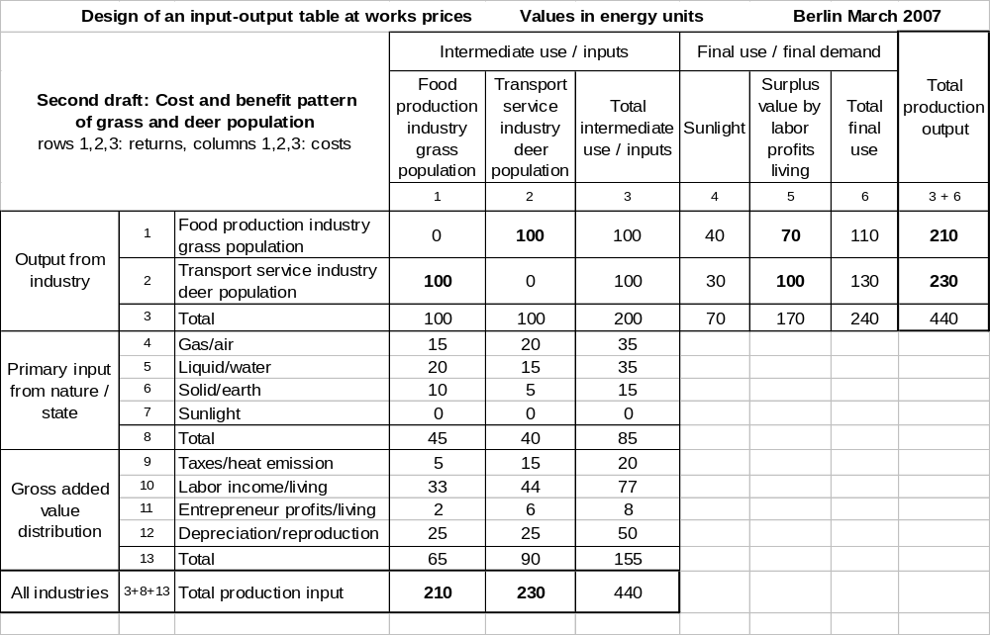
Table 7: Second draft of the design of an input-output table with grass and deer population

Now we can derive economic multipliers. To satisfy the intermediate demand of the deer population of 100 energy units (which the deer pay) the grass population produces a total output of 210 energy units, this is a multiplier of 2,1. The grass population covers the costs which are not balanced by the deer (210 -100 = 110), by direct returns from sunlight (40), and by its specific surplus value of energy by the production of its living biomass (70) which it is able to draw out from the input materials and sunlight. Vice versa, to satisfy the intermediate demand of the grass population of 100 energy units (which the grass population pays) the deer population produces a total output of 230 energy units, this is a multiplier of 2,3. The deer population covers the costs which are not balanced by the grass (230-100 = 130), by direct returns from sunlight (30), and by its specific surplus value of energy by the production of its living biomass (100) which it is able to draw out from the input materials and sunlight. The total production output of this economic system is 440 energy units. With a fictitious number of 30 deer for the deer population, we can measure the net wage rate per one hour of a deer by dividing the income and profits from living through this number, the number of days of a year, and the number of hours of a day, and we conclude (33+2) / (30 . 365 . 24) = 1,3 . 10 ⁻⁴ energy units, for illustration. Obviously, this economic system mapped by this table is driven by three parameters (forces), the exogenous (supply) parameter energy of sunlight, and the endogenous (demand) parameters surplus values of energy of grass and deer population which both have developed during evolution. Hence the ability to use sunlight efficient, and the ability to make an energy profit of materials which are transitory part of bodies of individuals of each population, are decisive for the existence and future development of each population. In other words: The supply of energy from sunlight and the demand for surplus value from (producing) life of (both) populations are driving forces within the economic order of this model. Part of the surplus value - think of the entrepreneur profits - can be used to adapt both populations to different market conditions, for instance in case of these dual markets run out of balance, or to react on unexpected events like changes in the price structure.

Analytic description

We extend the present drafts from two populations and industries to the totality of species and populations, and we control the results about the driving forces within the global economic order of the natural world. For this purpose we use a mathematical description. We introduce symbols instead of figures for the various specifications, and we refer to Leontief’s concept. In general: We use a notation which fits both drafts of the created input-output table. Matrices are denoted by big letters; the sign * denotes the transposed matrix of a given matrix; the letter I stands for the unity matrix; matrix elements are denoted by small letters with two indices on right hand side, the first one from left, i, denotes the row, and the second from left, j, denotes the column of the field where this element is placed within the matrix. Vectors are denoted by big or small letters but underlined, vector elements (equal vector components) are denoted by big or small letters with one index on right hand side which denotes the number i of the row and the number j of the column, respectively, of this vector where this element (component) is placed. We note that a vector is a special case of a matrix with only one row or column, respectively, hence the sign * for transposing a matrix makes also sense with vectors; usually we mean with a vector a column vector, and if not we use the sign * of the transposed matrix which transposes a column vector to a row vector. We use short descriptions for matrices and vectors without indices, in addition an element specific description with brackets around the entirety of these elements. If the indices i and j refer to industries, then they run from 1 to 2 with the 2 industries of grass and deer population, and from 1 to n with n industries/populations. Specific matrices and vectors: By X = ( x _{i j} ) we denote the matrix of transactions from population i to population j, for all populations, within this table these transactions are mapped in the fields of rows 1, 2 and columns 1, 2; we note in case of balance is X a symmetric matrix that is X = X* and x _{i j} = x _{i j} for all indices i and j which occur. By X = ( X _{i} ) we denote the column vector of total production output of all populations numbered by row index i, within this table this vector is mapped in the fields of rows 1, 2 and column (3+6). By X* = ( X _{j} ) we denote the row vector of total production input of all populations numbered by column index j, within this table this vector is mapped in the fields of row (3+8+13) and columns 1,2; we note, in case of balance within this closed cycle we consider, the elements of X and X*, respectively, coincide. By x = ( x _{i} ) we denote the column vector of final use and final demand, respectively, for all populations numbered by row index i, within this table this vector is mapped in the fields of the rows 1, 2 and column 6. By x _{s} = ( x _{i s} ) we denote the column vector of the net subsidy from sunlight (equal the bottom line of subsidy by and cost for sunlight) for populations numbered by row index i, within this table this vector is mapped in the fields of rows 1, 2 and column 4. By x _{p} = ( x _{i p} ) we denote the column vector of surplus values from labour and profits, respectively, of all populations numbered by row index i, within this table this vector is mapped in the fields of rows 1, 2 and column 5. By P = ( p _{i j} ) we denote the matrix of the primary inputs, row index i denotes the type, column index j denotes the population, for all four types i (gasiform, liquid, solid, sunlight) and all populations j, this matrix is mapped in the fields of rows 4, 5, 6, 7 and columns 1, 2 of this table. By V = ( v _{i j} ) we denote the matrix of the gross added value, row index i specifies the type (taxes, labour income, profit, depreciation), column index j denotes the population, within this table this matrix is mapped in the fields of rows 9, 10, 11, 12 and columns 1, 2. Now all specifications are denoted by symbols which directly occur in the design of the first and second draft of the created input-output-table.

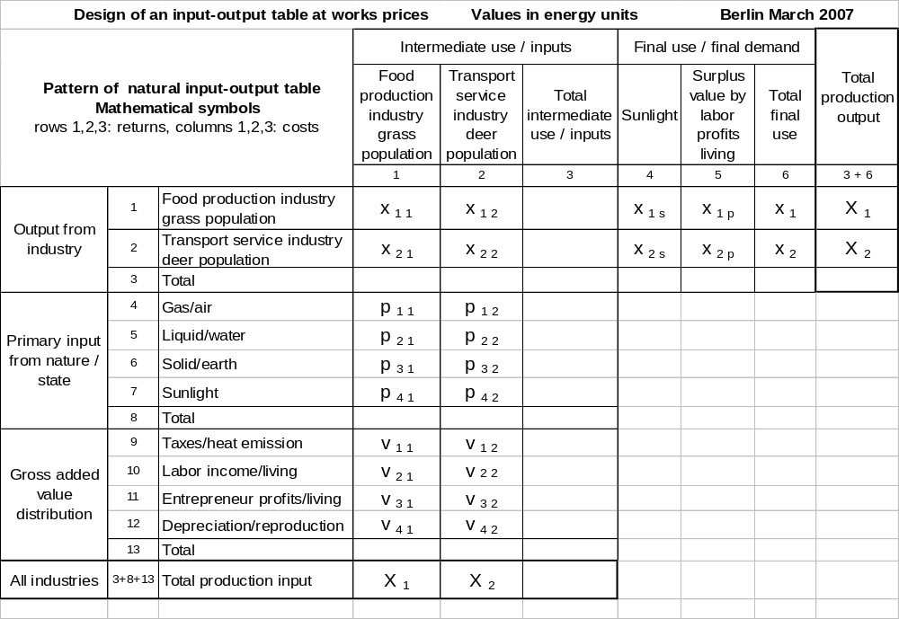
Table 8: Illumination of input-output symbols: Matrix of transaction X = (x _{i j}); column vector of production output X = ( X _{i} ); row vector of production input X* = ( X _{j} ); column vector of final use/demand x = ( x _{i} ); column vectors of net subsidy from sunlight x _{s} = ( x _{i s} ) , of surplus value x _{p} = ( x _{i p} ); matrix of primary inputs P = ( p _{i j} ); matrix of gross added values V = ( v _{i j} ).

Referring to Leontief’s concept, for further use we introduce two matrices and two vectors, in addition. We introduce the matrix of input coefficients, symbol A = ( a _{i j} ), by the definition a _{i j} = x _{i j} / X _{j} for all occurring indices i and j; and we introduce the Leontief’ inverse (matrix), symbol (I – A) ⁻¹ , which can be calculated by inverting the difference between the unity matrix I and matrix A according the operations noted in this symbol. We explain the meaning of both matrices: The element in row i and column j of matrix A, a _{i j} , measures the intermediate input in population j from population i in per cent of the total input into population j , X _{j} ; and the element in row i and column j of Leontief’ inverse measures how much the total production output of population i , X _{i ,} is to be increased and decreased, respectively, when the final demand for production of population j , x _{i} , is increased and decreased, respectively, by one energy unit. Furthermore, we introduce the matrix of output coefficients, symbol O = (o _{i j} ), defined by o _{i j} = x _{i j} / X_{i} for all occurring indices i and j. We note that the output coefficient o _{i j} measures the intermediate output from population i to population j in per cent of the total production output of population i, X _{i} . By tr . _{j} we denote the column vector which includes the input coefficients of transactions from all populations to population j, in addition the input coefficients of the primary input and of the gross added value in per cent of the total production input of population j, for all populations j in a period. By tr _{i} .* we denote the row vector which includes the output coefficients of transactions of population i to all populations, in addition the fractions of the two posts of the final use in per cent of the total production output of population i, for all populations i in a period. The abbreviation “tr” is derived from “trace”. We explain both vectors and hence the “traces” they represent: The vector tr . _{j} and his elements mark the energy trace which the species j leaves behind in the natural world during one period in order to produce living biomass (including services) of its own species for one unit of energy within this period, and hence consumes this energy unit as cost for allocation of goods and services, this trace we denote as input- or allocation-trace of species j. Reversely, the vector tr _{i} .* and his elements mark the energy trace which the species i leaves behind in the natural world in a period in order to distribute living biomass (including services) of its own species for one unit of energy to the intermediate and final demand/use, and hence gets back as return from the distribution of goods and services, this trace we denote as output- or distribution-trace of species i. How can we imagine these traces? Answer: Because energy is invisible, we look for observable and measurable impacts of these energy traces. We begin with the allocation-trace. For this purpose we imagine that one unit of energy is the energy which one deer as enterprise of transport industry has as total cost for its production input during one year. This deer allocates this unit of energy (presumably unknowing) to the different cost posts of intermediate input from the grass population (food), for primary inputs of gasiform, liquid, solid type, if necessary for sunlight, as well as to the different cost posts of the gross added value (taxes, labour, profit, reproduction) in this way that it is able to absorb required intermediate inputs and primary input, in order to be able to supply transport services. Thus the environment is changed because deer-typical inputs are missing which are observable and measurable, so grass is missing (by eating), as well as oxygen (by breathing in), water (by drinking), furthermore the deer is being changed as well (by growing older). These changes we call in parts (negative valuing) environmental degradation by the deer, it is an empirical evidence for the existence of the input- or allocation-trace. We continue with the evidence of the output- or distribution-trace. For this purpose we imagine that one unit of energy is the (by amount equal) energy which a deer as enterprise of the transport industry gets as total return from inter-mediate demand/outputs and from final demand/use within one year. In our model the intermediate demand is given by the grass population which demands for transport of its seeds and pays with the energy of the food grass, and the final demand is given by this deer itself which demands for the surplus value of energy from producing its own living biomass. Whether or not this deer, after absorbing the food and other primary inputs, books the surplus energy released by decomposition and composition of these materials as money for transport services or for its self-realisation, the environment is changed by the use of this released energy because there are deer-typical outputs which are observable and measurable: Used food, used solid material and water (by ejection of excrement and urine), used air (by breathing out carbon dioxide), footprints (by transport). These changes of the environment we call in parts (negative valuing) environmental pollution by the deer, it is an empiric evidence for the existence of the output- or distribution-trace. Because the existence of these traces are a strong support of the hypothesis of a global economic order within the natural world using

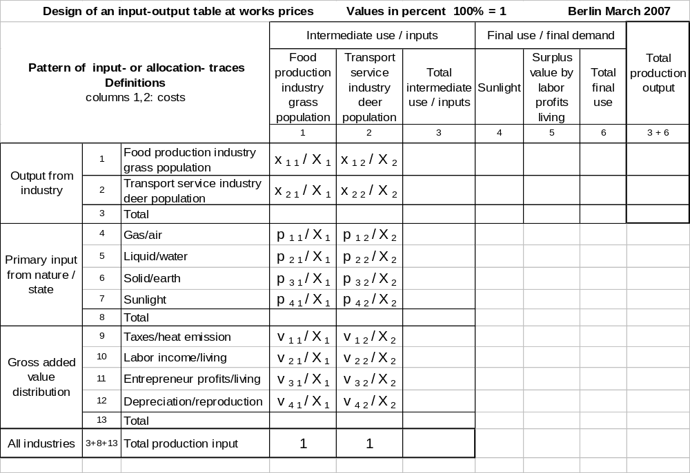

Table 9: Illumination of the symbols of the column vectors tr _{. 1} and tr _{. 2} marking traces of input or allocation of grass and deer population including elements of the matrix A = (a _{i j} ) = ( x _{i j} / X _{j} ) of input coefficients.

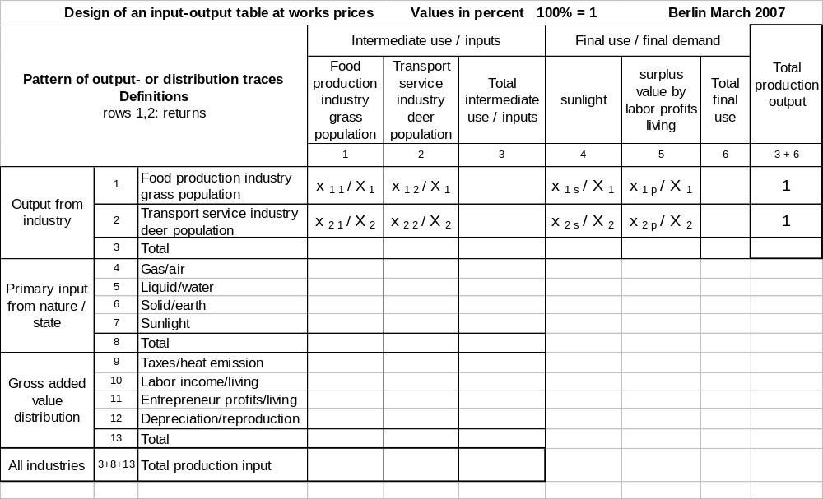

Table 10: Illumination of the row vectors tr _{1 .}* and tr _{2 .}* marking traces of output or distribution of grass and deer population including elements of matrix O = (o _{i j} ) = ( x _{i j} / X _{i} ) of output coefficients.

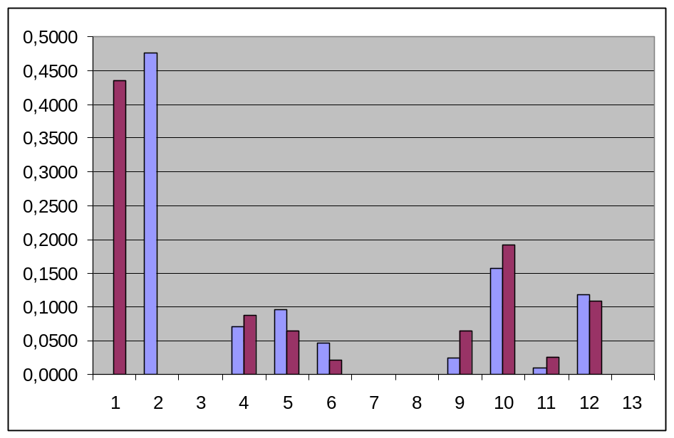

Picture 4: Graphical illumination of the vectors tr _{. 1} and tr _{. 2} marking traces of input or allocation of grass population (light blue coloured), and deer population (crimson coloured). The numbers on the abscissa refer to the row numbers in Table 9 and 11 which indicate costs in percent for special type of input (intermediate, primary, and for providing the gross added value). The scale of the ordinate is percent, 100% = 1. The columns show the allocation of energy for the different kinds of inputs within a period by the grass and deer population. According these fictitious figures both populations allocate the biggest parts for transport of seeds and for food, respectively, for labour, and for reproduction.

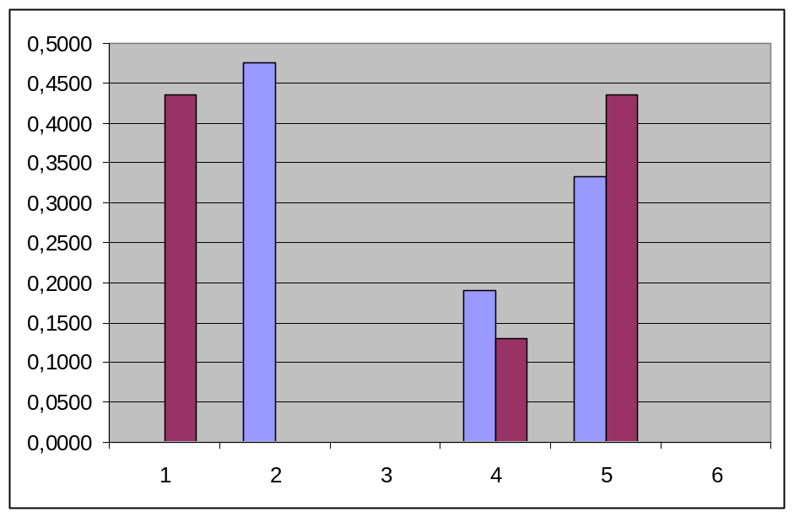

Picture 5: Graphical illumination of the vectors tr _{1 .}* and tr _{2 .}* marking traces of output or distri-bution of grass population (light blue coloured), and deer population (crimson coloured) using the figures of the second draft of the input-output table. The numbers on the abscissa refer to the column numbers in Table 10 and 12 which indicate returns (benefits) from intermediate and final use. The scale of the ordinate is percent, 100% = 1. The columns show the distribution of energy for the different kinds of output for intermediate and final use for grass and deer population. According these figures both populations distribute the biggest parts for their mutual intermediate output and self-realisation. The columns of position 4 represent the subsidy from sunlight.

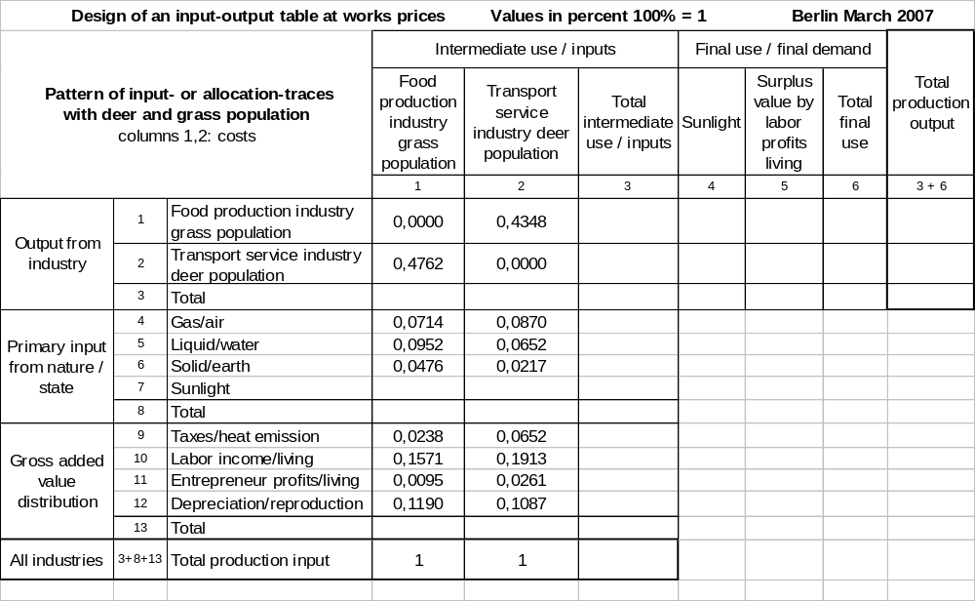

Table 11: Illumination of the column vectors tr _{. 1} and tr _{. 2} marking traces of input or allocation of grass and deer population using the figures of the second draft of the input-output table. The elements of the matrix of input coefficients A = ( a _{i j} ) are included in fields of rows 1, 2, and columns 1, 2.

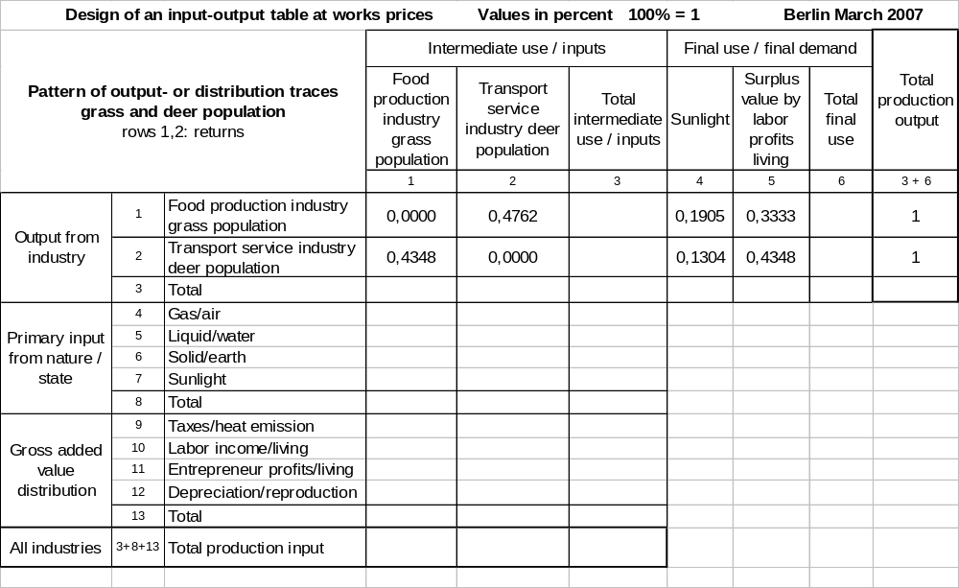

Table 12: Illumination of the row vectors tr _{1 .}* and tr _{2 .}* marking traces of output or distribution of grass and deer population using the figures of the second draft of the input-output table. The elements of the matrix of output coefficients O = ( o _{i j} ) are included in the fields of row 1, 2, and column 1, 2.

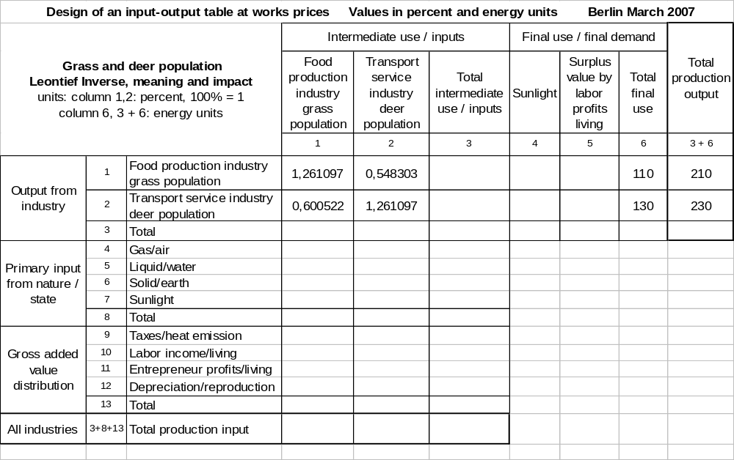

Table 13: Illumination of Leontief’ inverse matrix ( I – A ) ⁻¹ in rows 1, 2, and columns 1, 2 with grass and deer population, as well as the vector of final use/demand x = ( x _{i} ) in column 6 and vector of production output X = ( X _{i} ) in column (3+6). Note: The product of Leontief’ inverse matrix and vector of final use/demand equals vector of total production output: (I – A ) ⁻¹ x = X .

energy as equivalent of money, we illuminate these traces within a home of man’s economy: This home is produced by the building construction industry and used for private consumption. Traces of allocation are, for instance, missing stones on a stone pit which the building construction industry got as intermediate input from the industry dealing with stones and earth, missing trees in a forest which the building construction industry got as intermediate input via the wood processing industry, but also working places within the building construction industry; traces of distribution are, for instance, liquid waste of this home, the smoke coming out of its chimney, but also activities of living in this house. Depending on the perspective, we value these traces negative or positive. Result: Like any industry can be identified by a specific pattern of its traces of allocation and distribution, any species can be identified by a specific pattern of its traces of allocation and distribution as well. The overlay of the traces of all industries and populations of the natural world we observe and measure as changes of the environment, in parts as degradation (negative allocation-traces), and in parts as pollution (negative distribution-traces).

But there are more results from the analytic description. Using the introduced notations and elemental matrix operations for both drafts the following equations hold in each time period t:

X = A X + x or X = (I – A) ⁻¹ x both drafts

The left equation represents the balance of transactions, reading from left to right the meaning is that the total production output, X , is partly used for intermediate production, A X (think of grass which is eaten by deer, for instance), and partly used to satisfy the final demand x (think of the self-demand after self-realisation of a grass plant, for instance). The right equation is the solution of this balance of transactions after the total production output, X , this equation shows the dependence of this total production (within the natural world) from the final demand x for this production as well as from specific economic conditions of this production described by the Leontief’ inverse which itself depends from the matrix of input coefficients, A. The advantage of this vector and matrix representation is that the equations hold as well when we raise the number n of included populations from 2 (with deer and grass population) to all populations and creatures, respectively. Including one thousand species, for example, means that the vectors X and x , respectively, include one thousand components, and the matrices A and (I – A) ⁻¹ , respectively, include one million elements. If we refer to the figure of about 1,75 million of identified species, the size would explode to different dimensions. Moreover, if we consider the second draft, we can decompose the final use of life and bio-mass into its components from sunlight, x _{s} , and profit, x _{p} , by production of life, and we get:

X = (I – A) ⁻¹ ( x _{s} + x _{p} ) second draft.

The meaning of this equation is, from left to right: The total production output of living biomass (bodies and services of all creatures) in one period, measured and evaluated in energy units, in this open ended and static Leontief’ model depends from and hence is driven by two parameters or forces, one force is the supply of energy by the sun, x _{s} , the second force is the self-demand for the surplus value of living biomass of the creatures, x _{p} . Hence the economy of the entire natural world is driven by the supply of energy (money) from the sun and by the self-demand of the creatures for the surplus energy (profit) by producing living biomass able to provide services. This surplus energy (profit, money) the creatures can use to finance their existence on earth. The amount of this surplus value for each species depends from the specific pattern of the traces of allocation and distribution of all species, hence from their facilities to convert their inputs in their outputs profitably, and last but not least these facilities are restricted by the available primary input on earth. Thus we confirm the result derived from the model of grass and deer population with all species. We note that this result about the driving forces is compatible with and confirms the knowledge from physics and biology.

2 Summary and conclusion

By applying Leontief’s input-output concept to the postulated economic order within the natural world we were able to create the design of an input-output table for the involved grass and deer populations and their interactions. Because of real statistical data are not available, we demonstrated this design with fictitious figures in two drafts. Independent from this data we got remarkable results: Assuming that creatures work like enterprises and population like industries, we detected that they get a profit or surplus energy by producing living biomass of their own species. This profit is necessary to balance costs which are not covered by returns from intermediate outputs, hence they demand for this profit for self-realisation. This surplus energy or profit we could substantiate either by theory of surplus value of Karl Marx (1818-1883), or by theory of enterprises which are independent approaches. We found empirical evidence for the existence of this surplus energy with chemical actions and reactions, too. Without this profit the creatures could and would not exist as enterprises, hence they would not exist as creatures, too. We identified the cost of reproduction as the post depreciation within the input-output table, and the mean life expectation as the period of depreciation. We got the insight that all physical and chemical actions and reactions which are necessary to produce and restore life (the same as producing living biomass able to provide services) must have a positive bottom line of energy with every creature. This means that life on earth has an economic basis in the natural world, indeed.
Using the analytic description of an open ended and static Leontief-model we could extend the number of populations and industries from the two species/populations of deer and grass to all species on earth. Estimated with caution, there are about 1,75 million identified species living on earth, the precise figure is not clarified because of a lot of related creatures and populations, it is a very difficult task to get an estimation. So a world model including economic activities of all species could be mapped in an input-output table of this huge size as well as in one vector equation of the Leontief-model. Looking at the driving forces in the economic order of the natural world, we detected a) the supply of energy from sun via sunlight, and b) the demand of any creature for life and for surplus energy from producing living biomass for sake of self-realisation, respectively. The latter is restricted by the resources of the primary inputs on earth as well as by the bio-technological facilities of the creatures. This makes sense. We note that both driving forces are independent: Without sunlight, nothing runs on earth because of the creatures are not able to balance their high cost of living by mutual intermediate inputs and outputs, they need the sunlight (directly or indirectly) as subsidy. Reversely, without the self-demand of the creatures for self-realisation there would be no production of life on earth, too, the latter is self-evident. The ability to use sunlight efficient, and the ability to make profit of materials which are transitory part of the bodies of creatures, are decisive for the existence and further development of all species. However, part of the surplus values and profits, creatures must use to adapt their species to different market conditions in future, for instance in the case that the dual markets between two populations run out of balance, when there occurs a need to react on unexpected events, or simply to react on continuous changes in the price structure. An example we present in part 3, see Table B.
We learnt that creatures of a species can be identified and mapped by their energy traces they leave when they gather their inputs and consume their outputs. We identified them as economic traces of allocation and distribution they can be described by their specific input- and output-coefficients. Every population/species can be defined by a specific pattern of allocation- and distribution-traces, and by a specific operational concept to transform its inputs into its output. By these energy traces the entirety of species and creatures continuously changes the environment on earth. These changes are the observable evidence of economic activities of all species and populations. If a species or population is very large and predominant like human species, we observe these changes (indirectly) also as damages of the environment (degradation, pollution). Hence the creatures have a permanent need for adaptation. This conclusion is compatible with the theory of Charles Darwin (1809-1882) although we substantiated with economic arguments, only, and did not refer to his theory, this we note. In addition, we note that the used static description where all variables refer to values of the same time-period, t, can be extended to a dynamic description where variables may refer to different time-periods, for instance t, t-1, t-2, etc. but we do not deepen this approach here.
Finally we learnt that the picture of the natural world as it appears to us in present, can be explained and is nothing different than the overlay (or accumulation) of the energy traces of allocation and distribution of all creatures since the beginning of life on earth. The creatures left these traces because they wanted to be alive and were alive. Using energy from the sun and adapting themselves to the conditions on the earth they provided (and still provide) themselves the required surplus value of energy for their self-realisation by industrial self-production. Paradoxically is that the picture we have in mind when we think of a beautiful natural landscape (which we like), in reality is nothing different than a dual identification of a “destroyed and polluted” natural industry landscape (which we don’t like) of the entirety of species; like the phenomenon seeds of grass are waiting for transport is a dual identification of the phenomenon deer are grazing on a meadow. These dual identifications are not separable like upper and down side of a coin, and this coin is our earth. The natural industry landscape is working extraordinarily efficient empiric evidence is that it exists since millions of years.
What is the conclusion? Reminding the aim of Leontief’s input-output concept within this combined empirical and analytic approach and test, we see no reason to reject the hypothesis of a global economic order in the natural world with energy as price specification and money equivalent, and we accept it on this level. The arguments all in all as well as in detail are too convincing, they support facts we know from natural sciences (physics, biology) as well as from environmental protection. On basis of Leontief’s theory we have created the design of an input-output table including the activities of all species and populations of the natural world. By this we possess an instrument to comprehend other natural and social phenomena in a deepened way. To demonstrate its utility we apply this design to the actual phenomenon of bird’s death by avian flu.

3 Application to the phenomenon of bird’s death by avian flu

Subject and aim

The avian flu caused by viruses of type H5N1 also named poultry pestilence appeared in South East Asia in November/December 2003, and was propagated by migratory birds on their trans-regional routes until 2005/2006 to European countries. As it can not be excluded and is feared by scientists and the World Health Organization WHO that these viruses closely related to the human influenza may imperil even human beings and may be transferred by the latter, on level of agricultural and health policy, on national level, and on level of European Union this situation initiated a series of preparative measures more or less incisive up to prevent a possible pandemic and to develop specific serums. Daily newspapers and online-media detailed reported in 2005 and 2006 about steps and backgrounds of the propagation of these viruses (via Russia, Romania, Turkey etc.). They focused questions of protection of native poultry, especially of domestic chicken, ducks and geese, against these viruses (obligation to keep them in stables, prohibition of imports of poultry, controls at airports, controls of buses and cars at borders), they focused questions how people should behave themselves to exclude the risk of an infection (to avoid direct contact with poultry, to eat well-done meat of poultry, immunization), and they focused arguments of adequateness (a panic and the traffic on streets are more dangerous). Since about one year this phenomenon is out of public discussion but it is still present, in February 2007 there was a need to butcher ten thousands of turkeys in one of the largest poultry farms in Great Britain (source: Der Tagesspiegel online from 4th February 2007). Since the viruses of type H5N1 firstly appeared 1997 at Hong Kong, in Asia more than 60 people died from this disease (source: Basler Zeitung online from 11th November 2005). The questions asked in this application are different. Their aim is like in a mirror to reflect the observable natural phenomenon of „bird’s death“ in the economic order of the natural world. This mirror is represented by an input-output-table of the involved populations of edible grass plants, migratory birds, and viruses. Within this mirror we look for the economic reason of bird’s death by avian flu and other signals of this phenomenon, and we evaluate political measures.

Identifying the dual markets

Within a preceding micro-economic analysis of the food chain including (grass) plants, (migratory) birds, and viruses we have to identify the dual markets between these populations. Starting point are the observable phenomena of grazing migratory birds, of flying migratory birds and their migration routes, and the phenomenon how influenza execute reproduction on a host known from biological discipline. We begin with the identification of market and dual market between the limbs “plants” and “birds”. We identify the meadow where the migratory birds eat grass plants as “market place”, the market as a “food market”, the good as the food “grass”, and the grass population as “food production industry”; migratory birds represent the “demand” and grass populations the “supply” of this good and food “grass”. Looking for the dual market we see a “transport market” where the migratory birds represent the “supply” and grass populations the “demand” with the service “transport of seeds of grass” which allows the dual identification of the phenomenon of grazing migratory birds as seeds of grass are waiting for transport. Bird and grass population pay for the goods and services they demand for with money equivalent energy, by “being eaten” seeds of grass transfer the chemical energy of the grass in which they are included like in a parcel to the migratory birds, vice versa the latter transfer transport energy to the passengers “seeds of grass”. Considering the inseparably coupled dual markets “food market” and “transport market” as a closed economic model, and applying neo-classical theory these markets are in balance then and only then (perpetually and time-delayed if necessary) if the payments from the migratory birds to the grass population (plants) as well as the payments from the grass population to the migratory birds have a medium- or long-term balance in one period lets say one year; otherwise one of both concerned populations would drop out of these markets for lack of money (energy). Exemplarily we assume in case of equilibrium the amount of these mutual payments is 90 energy units per period and per population. We continue with the identification of the dual markets between the “migratory birds” and “viruses”. For this reason we imagine how a virus invades a host cell (of a migratory bird, for instance), how it eliminates different obstacles like entrance in and exit from this host cell, and how it uses the cell nucleus to reproduce its biomass. The benefit of the viruses is obvious; the migratory birds are “restaurant”, “hotel” and “means of transportation” for them. The host cells the viruses need for absorbing food and for reproduction. But how the viruses pay for these services? Where is the benefit for the birds? What kind of market is the dual market? As we have no idea we look at equivalent means of transportation in human economies, aeroplanes or cars, for instance. We observe: Aeroplanes and cars do not only get periodic attendance but also for safety not only of the passengers they are tested by inspections, periodically made by independent experts. With cars in Germany these inspections are well known as technical inspections which are made every second year. With the latter by scratching at brake lines, by hammering and stinging against iron plates it is tested, especially with older cars, whether these are strongly rusted and must be drawn out of traffic if necessary. Equally we conclude that the population of viruses not only those of bird’s infection are some kind of independent “enterprises for health inspection”, which come to creatures not only to migratory birds, and test whether their health is intact, especially their immune system, and whether they have to and are able to adapt to new requirements of life. This test and service consists of an “attack” on “host cells” according the present status of bio-technological development. Like in a “military exercise” the immune system of an infected bird tries to defend the “host cells” against the “attack” of the viruses, usually this is successfully in the end, so the infection is a transitory phenomenon which we call “illness”. Within these “military exercises” the immune system not only of birds trains the ability to remove “slight” and “considerable” defects like with the technical car inspection, and by this “illness” it acquires new bio-technological knowledge towards adaptation to future conditions (further education). This service of the viruses must be paid by the bird’s population (migratory birds), it is paid by the loss of energy the migratory birds suffer from “hosting”, “reproduction” and “transport” of the viruses. With it the bird population balances the loss of energy the population of viruses suffers from this “attack”. Thus the dual market is detected; we call it “services of healthcare and further education”. These services the birds and other populations demand for in spite of ignorance, and the viruses (as populations) supply them in spite of ignorance, too, “market places” are host cells inside the birds. Considering the inseparably coupled dual markets “services of restaurants, hotels, and of transport” and “services of healthcare and further education” as a closed economic model, applying neo-classical theory these markets are in balance then and only then (perpetually and time-delayed if necessary) if the payments (energy losses) from the migratory birds to the viruses and the payments (energy losses) from the viruses to the migratory birds have a medium- or long-term balance in one period let’s say one year; otherwise one of the both concerned populations would drop out of these markets for lack of money (energy). Exemplarily we assume the amount of these mutual payments is 10 energy units per period and per population.
As result we hold down: The food chain including grass plants, migratory birds, and viruses micro-economically can be described by two markets and their corresponding dual markets. The first couple is a “food market” and a “transport market” between the market participants grass “plants” and migratory “birds”, market place is the “meadow”. The second couple is called “services of transport, restaurants, and hotels” and “services of healthcare and further education”, between the market participants migratory “birds” and “viruses”, “market place” is the “inside of a bird”.

Creating the design of the input-output table

We turn to the macro-economic analysis of this food chain, for this purpose we extend our input-output table (of the second draft) to the three industries of plant, bird, and virus populations, imbed the identified markets and dual markets with the mutual payments of 90 energy units between plant and bird population, and the mutual payments of 10 energy units between bird and virus population, as assumed. Like in the previous example with grass and deer population, for all three industries we complete the cost pattern with fictitious figures, we transfer the cost of total production output to the posts of total production output, and we complete the benefit pattern by assuming corresponding surplus values and net subsidies from sunlight for the three populations. Table A shows the result and describes the role of grass plants, migratory birds, and influenza viruses in this food chain. On the one hand this role

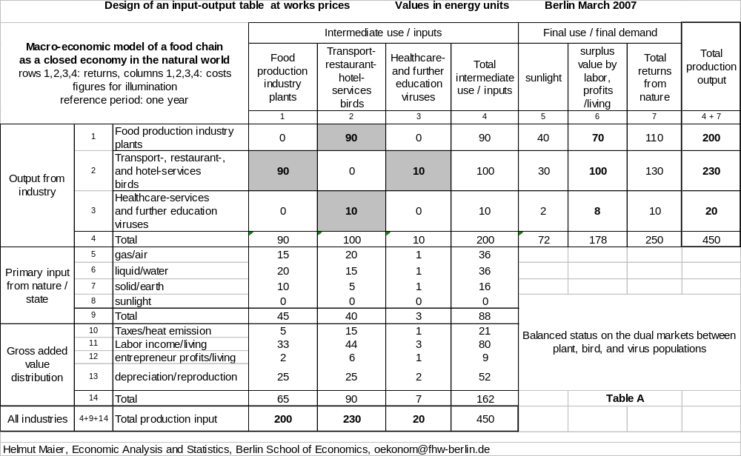
consists of the production of goods and services (intermediate inputs) for which they are suitable by their specific species, and which they supply to different suitable species (populations). Within this food chain grass plants are suitable to produce food; migratory birds are suitable to produce transport-, restaurant-, and hotel-services; and influenza viruses are suitable to produce services for healthcare and further education of birds; these products and services they supply (perhaps unknowing). On the other hand this role consists of the consumption of goods and services (intermediate outputs) which they need for life as a specific species. Within this food chain grass plants bound to a place need transport services to settle future generations at quite different locations; bio-technological highly developed migratory birds need the food grass as well as periodic services to test and improve their immune system; and so-called primitive organisms like viruses need restaurants, hotels, and transport; these products and services they demand for (probably knowing). However, the main role of these creatures (populations) consists of their self-realisation, they produce their own living biomass which they themselves demand for, they themselves consume, and hence have to finance themselves (perhaps unknown). For this financing, in case of balanced markets and dual markets they cannot budget returns from intermediate outputs to different populations/species because these returns are already calculated to cover costs of the same amount for intermediate inputs from these populations/species. Therefore, to finance their self-realisation, on the one hand they use energy from sun supplied by sunlight, and on the other hand they use the energy profit and energy surplus value, respectively, which they gain by species-specific physical and chemical procedures from their species-specific primary input in aerial, fluid, and solid form.

The three signals and the final reason of bird’s death

Using this table as a mirror what is the economic meaning of the phenomenon “bird’s death” caused by certain viruses of type H5N1? Access to the answer we find when we look at the dual markets in this mirror on which enterprises (creatures) of industries of birds and viruses interact by buying and selling services on the market place “inside of a bird”. The volume of sales on both dual markets is indicated in the fields (row 2, column 3) and (row 3, column 2) of Table A as 10 energy units for each which refers to the balanced case. The figure 10 of field (row 3, column 2) means that the viruses sell and deliver services of healthcare and further education (by attacks on host cells of birds to test and promote their immune system) to the birds for 10 energy units per period. The figure 10 of field (row 2, column 3) means that the birds sell and deliver transport-, restaurant- and hotel-services (to balance their losses from attacking host cells) to the viruses for 10 energy units per period. The observable phenomenon “bird’s death” ahead of time we identify as a signal that these dual markets are no longer in balance. Within these dual markets the economic meaning of this death ahead of time is that either the returns of the birds are too less or the costs of the birds are too high. Assuming the ceteris paribus condition of Alfred Marshall (1842-1924) for the different production process (of their living biomass) they can no longer exist as enterprises, drop out because of insolvency ahead of time, and get bankrupt. This imbalance of energy payments to the disadvantage or cost of the birds could be a marginal or a considerable one. As we can assume that birds’ population time-delayed could balance a marginal imbalance to their disadvantage (again) after Alfred Marshall by an elastic price-behaviour (energy-behaviour) via a further development of their immune system financed by reducing profits and labour costs (economization) - such a case exemplarily is shown in Table B - the further analysis focuses the case of a considerable imbalance, only. To Table B: The figures 11 and 9 in the grey fields of (row 3, column 2) and (row 2, column 3) state that the birds pay 11 energy units for the services of the viruses, reversely their returns from services to the viruses are 9 energy units, only. The figures 43 and 101 in the grey fields of (row 11, column 2) and (row 2, column 6) state that the birds balance this higher cost (11 instead of 10 in Table A) by reducing labour cost (43 instead of 44 in Table A) and by improving the surplus value of total production (101 instead of 100 in Table A). The figures 3,5 and 1,5 and 7 in the grey fields of (row 11, column 3) and (row 12, column 3) and (row 3, column 6) state that the viruses because of lower cost for intermediate input from birds (9 instead of 10 in Table A) increase labour income (from 3 in Table A to 3,5) and entrepreneur profits (from 1 in Table A to 1,5), and reduce the surplus value of total production (from 8 in Table A to 7). Thus the balance of total cost and return is given again for both populations, and the economic cycle works.

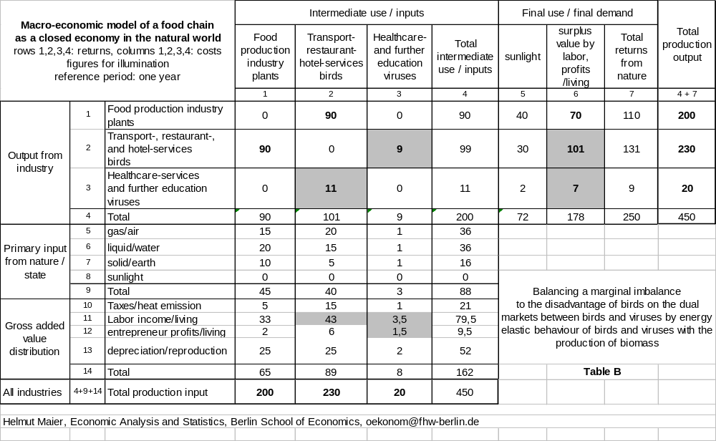
Where do these sudden additional costs of the birds for services of the viruses come from? Aim of these services is yet to conserve the health of the birds in long-term by current tests of their immune system and adaptation to the bio-technological progress if necessary. Access to the answer we find when we consider the markets where these viruses appeared firstly. According messages in daily newspapers this virus infection firstly appeared as so-called poultry-pestilence and chicken pestilence in 1997 at Hong Kong. These dual markets where chicken-birds and viruses interact have the characteristic that chicken-birds are linked with human economy because of they are domesticated, and hence “off the nature” (denaturising). The chicken-birds once in former times included in the natural industry transport-, restaurant-, hotel-services within this input-output table like the migratory birds until today, nowadays are object of production of human agricultural industry and included in the input-output table of a human economy. Hence they are subjected to conditions of production and life on quite a different level of innovation. Except for indispensable operations like picking up and breathing they do not need and are not able to take care of their primary inputs and required intermediate inputs (food, healthcare-services) by themselves because of they are caged up, usually, and nearly excluded from the natural world. On this level of innovation, the inputs necessary to produce their biomass, primary and intermediate ones, are provided by human who represents the final demand for their biomass within human economy as well. By this different level of production the self-realisation of the chicken-birds who before domestication themselves represented the final demanded for their biomass, and themselves financed their biomass is no longer given, the chicken-birds get a so-called shock of innovation, firstly, and then they mutate themselves step by step. Their immune system is being used to be supported by medicaments given with the food; the continuous adaptation to the bio-technological status of development outside in the nature remains undone. By this extensive separation between natural markets and markets ruled by human domesticated chicken-birds continuously get more vulnerable for illnesses. They are bio-technologically inferior against attacks of viruses which in the nature serve their healthcare and further education. Surely, these attacks are rarer but yet they are possible via breathing or a different contact, for instance; evidence for this is the poultry pestilence. The domesticated chicken-birds are not able to finance the immense energy costs to combat the viruses, and they die. Such a case of a considerable imbalance exemplarily is shown in Table C. The grey fields mark changes to the balanced status of Table A. As for the birds, the balance of total cost (235 energy units in field of row 4+9+14, column 2) and total return (225 energy units in field of row 2, column 4+7) is not given, in spite of elastic behaviour they are not able to cover their immense cost by their returns, they exit from the market. As for the viruses, the balance of total cost (15 energy units in field of row 4+9+14, column 3) and total return (25 energy units in field of row 3, column 4 +7) is not given, too, but in this model they don’t exit at once from the market because of their immense return, only after the exit of the birds. Shown is a case where the total production output of both industries remains constant (450 energy units per year in field of row 4+9+14, column 4 of Table A and Table C), we note.

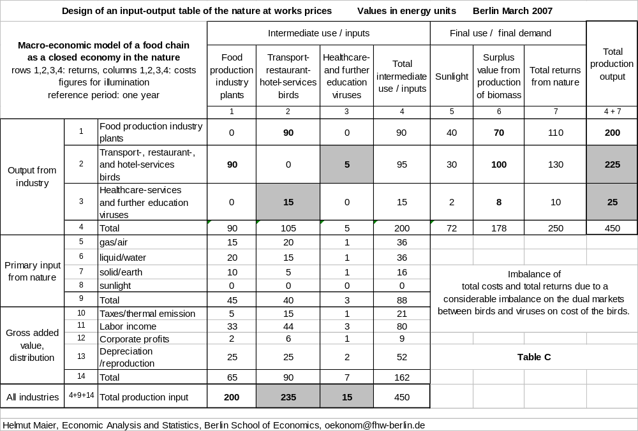

What is the benefit of the viruses from poultry-pestilence? Firstly, their energy return is exceedingly high. This they use for an extended reproduction which is far over the losses they suffered from the attack. This over-proportional reproduction is necessary because of their host’s near exit (bankrupt) they can use his services for a limited time from now, only, and they have to look for a new host and client. Yet this reproduction is being done within host cells of the human production object chicken and not in those of a wild living chicken, this characteristic is decisive. Therefore, secondly, while made from biomass of host cells by this procedure the reproduced viruses include bio-technological knowledge about production in human economy. With possible mutations and intermixtures of different tribes of viruses the development and bio-technological rearmed viruses which migratory birds do not know until now is possible and likely. Via contact to “enterprises of local traffic”, visitants, these viruses contact “enterprises of long-distance traffic”, migratory birds such as ducks and geese; along the routes of these birds they can execute their services for healthcare and further education (by tests with innovative “arms” still not known by different populations) nearly world wide. Testing migratory birds for sake of healthcare by further development within human economy these viruses have an innovative advantage. These tests and “attacks” on migratory birds no longer act like periodically expected “exercises” to control and to develop further their immune system, but rather act like an innovative shock as well. Reversely, now the migratory birds are negatively concerned as well as the chicken before, they are not able to finance the enormous energy cost to combat these new viruses and they die. Thus as reason of bird’s death we identify, finally, the far advanced separation of human economic order from the economic order of the natural world caused by industrial innovations of man to his own advantage. Obviously, this separation is a considerable thrust (in German: “Vorstoss”) and violation of legal rules (in German nearly equal: “Verstoss”), respectively, within the global economic order which challenges a sustainable reaction of the superior “natural state”. Knowing this reason the phenomenon of “bird’s death” is also a signal for this reaction. The term “bird’s illness by H5N1 virus” describes measure (illness) and instrument (virus population) of this reaction which in single cases also concerned human beings when contacted by infected birds.

What is the aim of the “natural state” with this reaction? Its top aim yet is conservation of life and not its obliteration. The “death” of a lot of representatives of populations is like a “punishment” and contradicts the (human) principle of rehabilitation. An answer to this question is important to evaluate the success of political measures to protect human and environment against avian flu initiated by human society. Access to this answer we find when we look at further impacts within the natural world in case of no intervention by human. Without doubt the species and population of birds is a highly developed technological industry within the economic order of the natural world. Representatives of bird’s species can fly far and high and they are mobile with fast reactions to an extent like human beings are not without using their innovative technique developed by them, at least. Bird’s populations exist, live and survive, since millions of years. Presumably they survived quite a big number of innovative mutations and shocks. Taking this economic experience into account we can assume that bird’s species and populations, respectively, time-delayed will balance their energy deficit on the dual markets “services for healthcare and further education” and “transport-, restaurant-, hotel-services” on which they co-operate with the population of viruses. By developing antibodies etc., step by step they will adapt their immune system to the bio-technological status of human economy, they will balance the innovative advantage of the viruses caused by human economy, and they will become resistant in the end. When this status is achieved already two populations, of viruses and of birds, have overcome the separated bio-technological development caused by man and are immune. Continuing this scenario as medium-term aim of the reaction of the “natural state”, we recognize the dissemination of new bio-technological knowledge under all concerned populations in order to balance competitive disadvantages. Certainly, this information-service of the “natural state” must be paid by all populations, they pay with the energy of the biomass which is given back to the environment (hence to the natural world) by those representatives of populations which ahead of time exit from the economic competition. This procedure is observable as “bankrupt” of single enterprises of type “migratory birds” and as “death” of creatures of type “migratory birds”, respectively; a mass exodus ahead of time indicates high cost. A reduction of the rate of infection of birds (and representatives of different populations including man) indicates the progress with the dissemination of this bio-technological knowledge, and hence the progress of overcoming negative impact of this separation of human economy from natural economy. Thus the “natural state” time-delayed achieves again an equilibrium of bio-technological knowledge among all concerned populations, and balances considerable competitive advantages of certain industries, respectively, in this case advantages of human species gained by separation from the economic order of the natural world. Therefore, this reaction finally yet serves the top aim conservation of life though under further developed conditions of production caused by technological innovations, and for which the creatures as industries and enterprises have to adapt themselves. Thus man’s action of separation of human economy above firstly called obvious violation of legal rules, now is identified as a violation of competitive rules, hence the sustainable reaction of the “natural state” is identified as an intervention by competitive rules to eliminate negative impact of this violation (and not to eliminate life or to punish populations). Both, the violation of competitive rules by man and the intervention by the natural state, for all populations and industries lead to an advanced bio-technological level of production changed by innovations, and hence to a rehabilitation of all further educated and surviving populations and creatures on a new level of economic development at all. In biology this development substantiated by purely economic arguments in this context, is known as evolution of creatures; therefore, the theory of evolution of natural sciences appears as counterpart of the theory of innovations of modern industry economics. From this point of view the natural phenomenon of “bird’s death”, thirdly is also a signal that the evolution of creatures achieves a new level. However, with the present status of “bird’s death” this level is evaluated as marginally different, only; the status of a pandemic would change this evaluation.
As for the evaluation of political measures how to react on dangerous impacts of avian flu to human beings, immunisation by adequate and weakened viruses of type H5N1 turns out as best mean because it supports the detected aim of the “natural state” of dissemination of new bio-technological knowledge.

Closing remarks

What’s Leontief’s heritage within this analysis? Answer: Applying his (open and static) concept on the macro-economic description of the dual markets of grass and deer population we were forced to give an evident answer to the open question how creatures identified with enterprises can balance their costs of production which are not covered by their intermediate outputs, see Table 5. As the creatures exist; such a solution had to exist, too. We found this solution; we could substantiate the missing post with the returns of both populations as a surplus value of energy by producing living biomass with obvious theoretical and empirical arguments. As Leontief’s concept easily can be extended from two to all populations or species on the earth, we found the design of the input-output table of the entire natural world including all species or populations as industries, and we found the driving forces: energy from the sun via sunlight, and the demand for life of the creatures. Because of these driving forces confirmed results of natural sciences (physics, biology), and because we could identify industrial traces of allocation and distribution of all species, we could accept the hypothesis of an economic order within the natural world with energy as money equivalent. We could prove the utility of the design of this input-output table by applying it to the present phenomenon of bird’s death by avian flu. We got useful insights: The food chain with grass plants, birds, and viruses represents several industries (food production, transport goods and services, hotel/ restaurant-services, further education and health inspection) which interact with mutual advantages. We learnt the positive role of (in our eyes only) dangerous viruses including these of type H5N1 within the evolution of species which is to propagate new bio-technological information by periodic inspections of all creatures. We learnt that the final reason of bird’s death is human because he separated its economy from the natural one by industrial innovations. We learnt the three signals of bird’s death from the natural order: the first that the dual markets between birds and viruses are out of balance, the second that the “natural state” (using virus species) reacts on a violation of competitive rules by human, and the third that the evolution of species will reach a new level by further education of all species. Thus Leontief’s input-output concept is suitable to break down the wall between natural and economic sciences. Accepting the hypothesis of an economic order within the natural world means, in addition that we can apply economic theories including their results in natural sciences as well and not only reversely. Hence this knowledge opens a wide field for research to comprehend social and natural phenomena of present which are big challenges for human societies in a different way.
To illuminate the latter idea, briefly we note some intermediate results of this research (Maier, 2006, p.65-76): Reason of the crowding phenomenon of the world population in present is that the human species is absolute winner of the economic competition of species within the natural world. Hence the production of human biomass increases and that of different species decreases. Reason of the ageing phenomenon, especially in high developed human societies, is the lack of energy of the economic active population to meet the top aim “conservation of life” by reproduction because the human social state, persecuting different aims, detracts its people too much energy by mostly social transfers amongst others to the preceding generation. Reason of the migration phenomena, especially migrations to high developed human societies, is that emigrants and immigrants assume to spend less energy for life elsewhere, hence have better conditions. Reason of the poverty phenomenon is a special measure of wealth and poverty (gross domestic product per capita) of human which doesn’t correspond to the measure in the natural order (which is the energy of gross biomass per area unit), the latter leads to a different result and a different ranking of countries. Unemployment is produced by human and an unknown phenomenon within the economic order of the nature; creatures have to work for whole life. Reason of the observable phenomenon of change of climate is amongst others that the entirety of economic activities of populations, especially of the leading human species, releases a lot of money (energy) in the natural world. Reason of the natural phenomenon of devastation of regions is that in these regions only few populations are able to balance their high (energy) cost for living by their (energy) return. Reason of the phenomenon of distinction of species is that their specific surplus energy from production of life they demand for is or was not big enough to react flexible on unavoidable increases of prices (in energy units) within the natural world.

Bibliography

- Leontief, W.: Input-Outout Economics, New York Oxford University Press 1966.
- Maier, H.: What is the money equivalent in the nature? Results of a hedonic approach. Paper presented to the 54th Session of the International Statistical Institute 13-20 August 2003 Berlin, Werkstatthefte aus Statistik und Ökonometrie, ISSN 1439-3956, August 2003.
- Maier, H.: Economic explanation of natural and social phenomena. Paper presented to 15th International Conference on Input-output Techniques of International Input-Output Association (IIOA), June 27 - July 1, 2005, Renmin University of China in Beijing. Werkstatthefte aus Statistik und Ökonometrie, ISSN 1439-3956, June/October 2005.
- Maier, H.: Introduction to nature’s economic and financial system. Features, impact on human society and politics. Werkstatthefte aus Statistik und Ökonometrie, ISSN 1439-3956, March/April 2006.
- Maier, H.: Bird’s Virus Infection Reflected in the Mirror of Natural Economics (English Version), Werkstatthefte aus Statistik und Ökonometrie, ISSN 1439-3956, April 2006; Russian version entitled “Avian flu in relation to natural economic order” in Aktualni Problemi Ekonomiki 7(61) 2006, p.173-189; Chinese version entitled “The natural economics, food chain and bird’s virus infection” in Finance and Economics, Sixth issue June 2006, ISSN 1000-8306, p.50-57.

Contents

Preliminary remarks 1
on axioms
on the evidence of energy as price specification
on the evidence of the payment transfer
on the result of the micro-economic description
on the aim of this analysis

1 Creating the design of an input-output table of the natural world 4
Approach 4
Matrix of transactions 6
Cost pattern 6
Benefit pattern 8
First draft and second draft 12
Analytic description 13

2 Summary and conclusion 20

3 Application to the phenomenon of bird’s death by avian flu 22
Subject and aim 22
Identifying the dual markets of the food chain 22
Creating the design of the input-output table 24
The three signals and the final reason of bird’s death 25

Closing remarks 29
on Leontief’s heritage
on other results

Bibliography 30

